# Principle of the lift/drag force sensor

When a model is placed on the support, the lift force induced by the model will displace the support (the mobile stick), this movement will deform the strain gauge attached on the support fixed on the bench, thereby, this deformation is relayed to a control card. The control card will convert this deformation into a force.

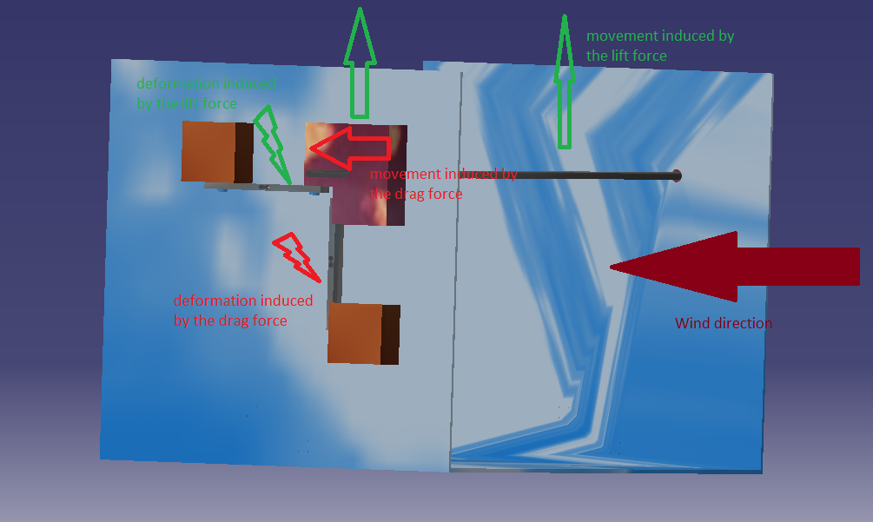

The shaped bloc is the mobile support. It move alongside the stick supporting the model. The two orange blocs are the fixed support. They are fixed to the support in order to deform the load gauge.

Note the two gauges (lift force gauge and drag force gauge) cannot be used the same time because they prevent the mobility of the mobile support. The fasteners of the model, and the different support are not show on the 3D model because there is lots of type of fixation. The easiest way is to fix the orange support to the main support with screw and link the mobile support and the model support with bolt and break washer. The couple bolt, break washer can also be used to maintain the position of the model on the model support.

Components:

* 2 strain gauge, the phidget CZL616C can be used: <https://www.phidgets.com/?tier=3&catid=9&pcid=7&prodid=223>
* 1 control card , the phidget 1046 bridge can also be used: <https://www.phidgets.com/?tier=3&catid=98&pcid=78&prodid=1027>
* 4 fixed support, those support can be obtained by machining a bloc of bloc of metal;
* 2 mobile support that can also be obtained by machining a bloc of metal;
* 1 model support it is a threaded shaft, bolt can be used in order to fix the model on the support;
* 1 support, this piece can be created by bending a metal plate.
* 8 screw in order to fix the load gauge to the supports;